
National University Of Modern Languages, Islamabad

User Experience Design (UXD)

Lab Task 4
Task: Ecommerce mobiles App
Name: Zulqarnain Hassan
Class: 6A Afternoon
Roll no: SP-21379
Assigned Date: 27 Feb 2025
Deadline: 01 March 2025
Figma Design Link: https://www.figma.com/design/5jCtVxiOwlpKD2tyHX7IhI/Untitled?node-id=71-255&t=OWJIHIGqRCf5MwPc-1

Marks Obtained
Remarks

Issues:

Design Screenshots:
Page 1: Home screen
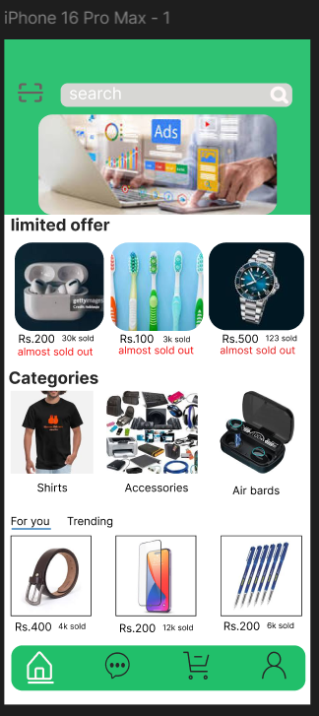

Page 2: Messages
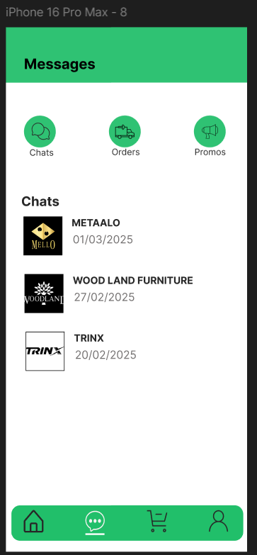
Page 3: My cart
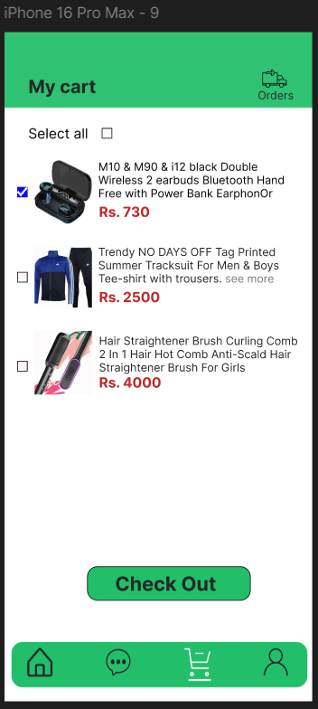
Page 4: Check out
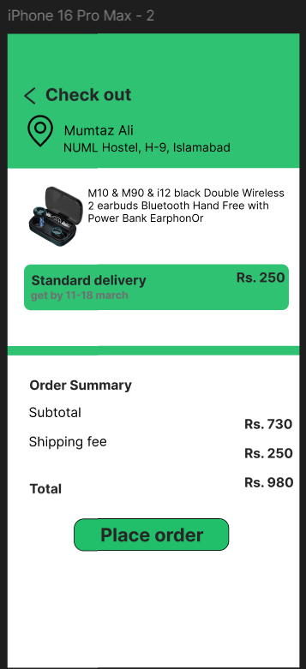

Page 5: Payment method
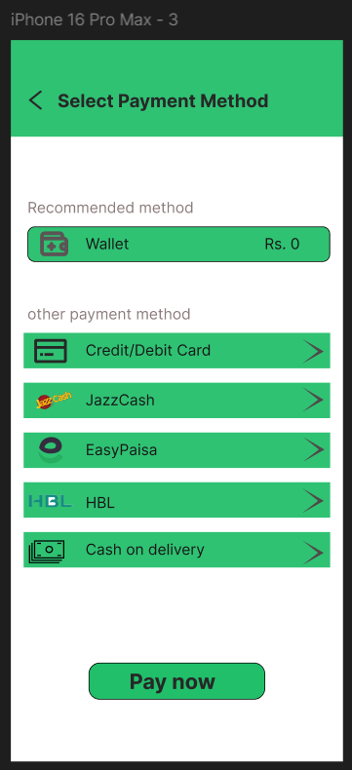

Page 6: Credit/Debit Card information form.
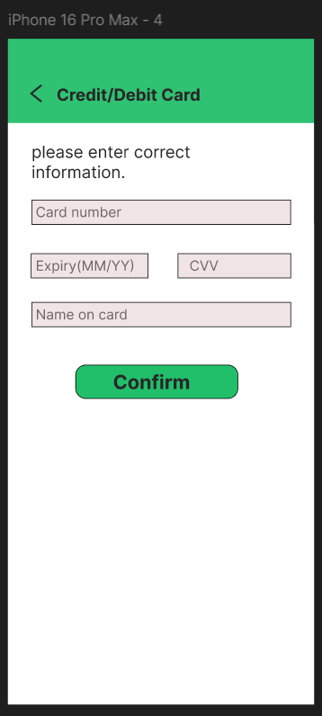
Page 7: Approval feedback (feedback type)
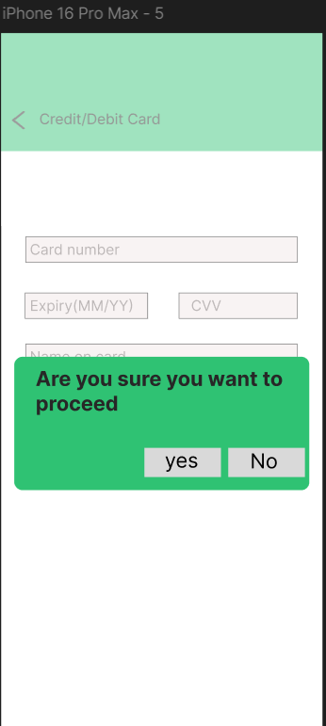
Page 8: Confirmation
